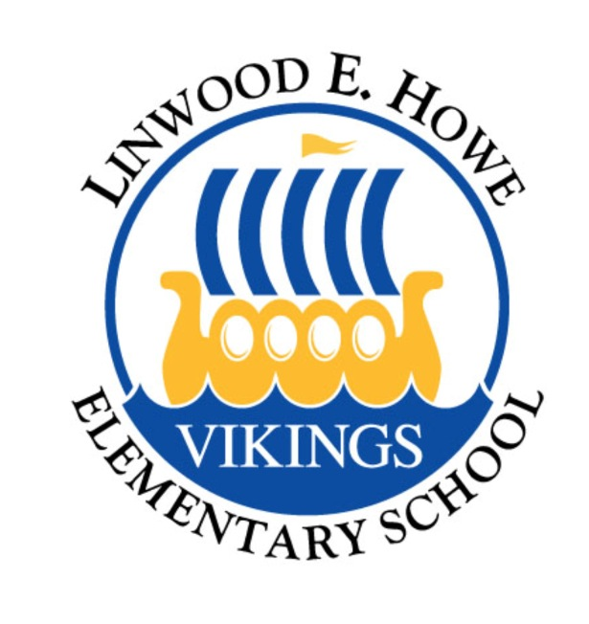

Kindergarten Ice Cream Social

Please join us for an afternoon of fun and ice cream, as you meet your new teachers and new friends.

When: Sunday August 16, 2015
Where: LINWOOD E. HOWE SCHOOL

Time: 3 pm–4:30pm

Please RSVP by August 10 to Celeste McVey at 310-895-5591 or cmcvey@ca.rr.com.

(If you are unsure if you can make it feel free to just show up that day.)

SAVE THE DATES:
• Back to School Night – Wednesday, September 2, 6-8 pm
• New Parent Orientation (option 1) – Wednesday, September 9, 5:30 pm
• First PTA Meeting – Wednesday, September 10, 6:30 pm
(child care provided)
• New Parent Orientation (option 2) – Friday, September 11, 9 am

